Team-1 - George Garrett, Jake Morris, James Pangia, Dennis Parkman, Zeenal Prajapati

Prof. Richardson

Class - CSCI 4320

April 25, 2022

**Frontend classes**

**Backend classes**

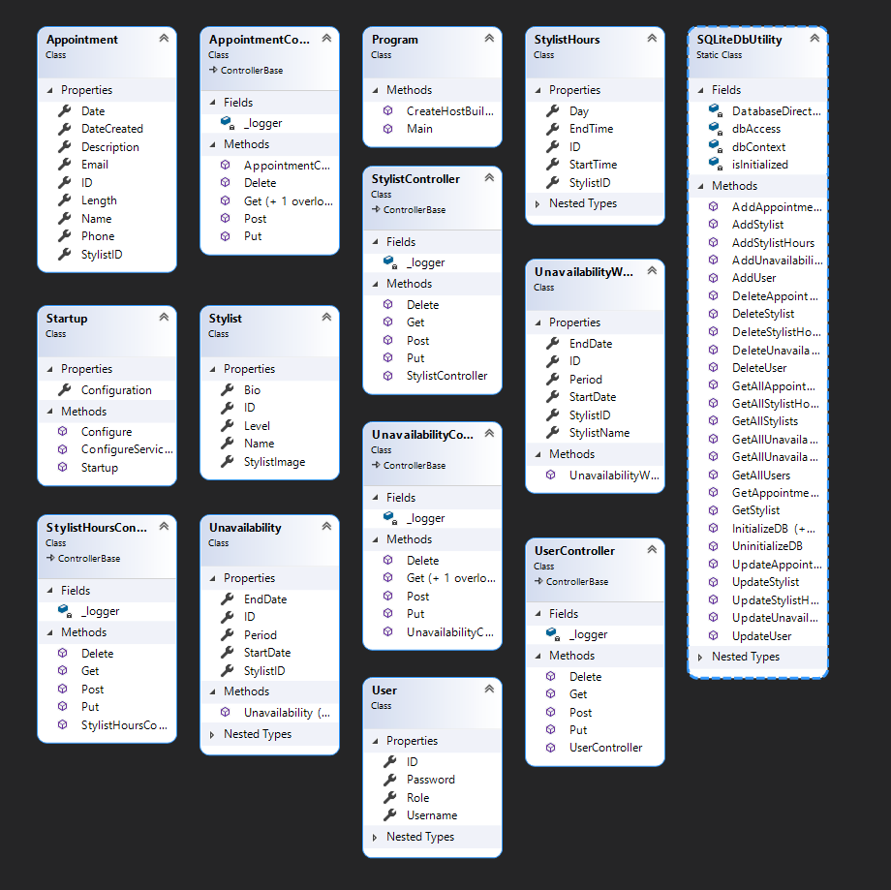

**Backend Unit Test class diagram**

